University of Missouri-Kansas City Spring 2022

**ME 459/5559 – Robotics and Unmanned Systems HW #3: DUE September 20th, 2022**

**LATE HOMEWORK WILL BE DEDUCTED 10% PER DAY AFTER THE DUE DATE**

Problem 1:

Modify your Dijkstra’s software to run the A* algorithm. This should require only small modifications to the cost estimate for each cell. Rerun the same simulation environment as Problem 4 and show the x vs y graph. Put the image of the path in the document here.

Send a link of your code from your Github repo.

<https://github.com/asd109a/anh_doan_unmanned_systems/blob/379a48c208c6436fcd27bc93fd25deb42315135f/anh_doan_unmanned_systems/anh_doan_unmanned_systems/home_work_3/question%201.py>

Problem 2:

Given the map below, and a grid spacing of 1, use A* to compute the path **(by hand)** from start to finish (start = red, goal = blue, obstacles = black).

Show your work (i.e. show the travel cost, heuristic cost, and total cost for each node visited).

0

1

2

3

4

5

6

7

8

9

10

0

1

2

3

4

5

6

7

8

9

10

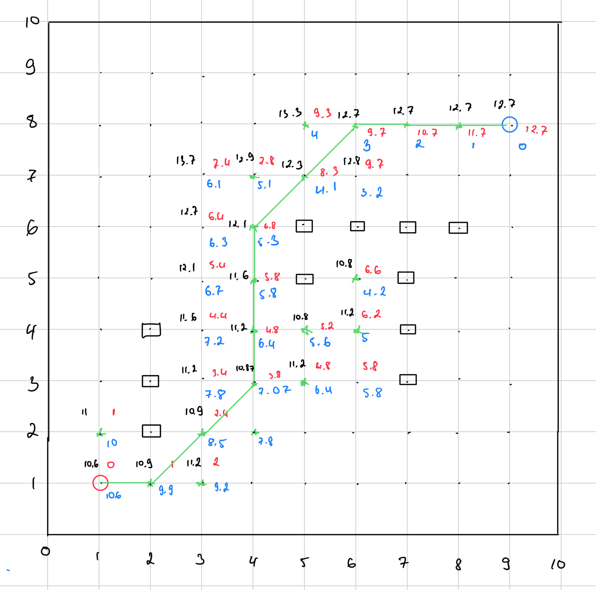

$$f\left(r\right)=g\left(r\right)+h(r)$$

g (r) is traveled cost so far. h(r) is heuristic distance to goal. f(r) is total travel cost.

$$h\left(r\right)=\sqrt{{\left(x2-x1\right)}^{2}+{\left(y2-y1\right)}^{2}}$$

Problem 3:

Modify your Dijkstra/A* code to use the RRT method to get from the start to the goal. Use the same obstacle list and bounding box. Use a distance to jump (from nearest node in the tree) of 0.5.

Create a plot showing the tree (valid nodes) and the corresponding path to get from the start to the goal for the same map as Problem 2.

Send a link of your code from your Github repo.

<https://github.com/asd109a/anh_doan_unmanned_systems/blob/379a48c208c6436fcd27bc93fd25deb42315135f/anh_doan_unmanned_systems/anh_doan_unmanned_systems/home_work_3/question3_.py>